COP CONDO ASSOCIATION MEETING MINUTES for Saturday 06.24.23 @ 9:30 AM at
Davis’ 12711 W Castle Rock Dr
Please use our website: “copcondo.org”

RECOGNITION OF VISITORS: President Ken Davis welcomed all visitors.
CALL TO ORDER: President (Ken Davis): at 9:33 am
RESIDENTS PRESENT: Lee and Roger Cousins, Abel Alday, Dale Stroh, Sharon Hicks and Sharon Davis.
BOARD MEMBERS PRESENT (Establish Quorum) Pres. Ken Davis, Jan Nelson, Patricia Sannerud and Myra Fribourg were present, establishing a quorum. Jerry Phipps was on vacation.
APPROVAL OF MINUTES: (SECRETARY: Myra Fribourg) Myra Fribourg called for Board approval of the Regular Meeting minutes for 22 April 2023. Ken Davis moved for approval, Jan Nelson seconded. The Minutes will be posted on our website “copcondo.org”.
PRESIDENT’S REPORT: (Ken Davis)
- We have new residents in the community. Ann Parent moved into 12510 Prospect (former Dyksterhouse residence). Terrie Luna and Sharen Hicks moved into 12715 Castle Rock (former Shapiro residence). We will have Douglas and Tamara McVey moving into 12514 Prospect (former Kregel) soon. Please welcome our new neighbors as opportunity permits.
Treasurer’s Report: (Pat Sannerud)
- March Financials were Approved on a motion by Ken Davis, seconded by Jan Nelson.
- Review of Financials for April and May.
  - See Balance sheet for April at the end of Minutes
  - See Balance sheet for May at the end of Minutes
c. Disbursements for April include:
- Beesvillebee farm for $300
- Loma Verde invoice for Shrubs
  - Loma Verde invoice for Irrigation
d. Disbursements for May include:
  - Loma Verde invoice for Tree Maintenance $1760
  - Colby Mgt for Income Taxes & Annual ACC Report Filing $65

COMMITTEE REPORTS:
ARCHITECTURAL (Jerry Phipps, not present.):
- New Architectural Requests submitted since the last board meeting:
(Jan Nelson for Jerry Phipps) Lee and Rogen Cousin submitted an AR to add a concrete patio and a sod or rock area between the patio and two citrus trees where grass doesn’t grow well. After much discussion, the concrete patio was approved. On 30 June, the Grounds committee approved the Cousin’s request to add sod (not rock) with half of the cost to be paid by the Cousin’s.
- Approved Architectural Requests completed since the last Board Meeting:
- Charlotte Bailey and Nora Guest installed a new shingled roof
- Jan Nelson replaced her black screen door with black security door
- Ken & Sharon Davis replaced their roof mount heat pump
- Homeowners are reminded that an Architectural Request must be approved by the Board before any new exterior projects are started.
- Deadline for Architectural Requests is one week before the next BOD meeting which will be in October.
GROUNDS (Jan Nelson):
- Water use report and discussion for April-May: April water use was down from previous years and May up as it is every year at this time. Overall water use for this year is less than same time last year. We have had several major valve fixes and breaks that have been taken care of these last couple of months.
- Status of Tree Trimming and Shrub Replacement. Planned shrub replacement completed.
  - Status for removal/trimming of trees and shrubs: Finished planned-for shrubs
  - Status for replanting trees and shrubs. It was decided to wait until the Fall planting season to plant shrubs on Omega and elsewhere. Jan Nelson recommended approximately 11 trees be planted in the coming year, 6 now and 5 later. Myra Fribourg so moved and Jan Nelson seconded.
- Citrus tree gleaning and trimming completed.
- Status of bee removal at 12626, 12618, and 12610 Prospect by Beesville Bee Farm (Scott Clark). Completed.
- New beehive at 12502 Prospect. Ken met with Barbara Saillard and she said this was not bothering anyone and no immediate action is required. Later Ms. Saillard sent an e-mail adding that while she was not bothered by the bees, while others might be.
- Discussion ensued and it was decided to defer possible removal and to order Caution signs be placed near bee areas, as has been done on the Golf Course. Patricia Sannerud will contact sign vendor.
- Outdoor hose bibs: Myra Fribourg brought up the fact that many of our outdoor hose bibs are 40 years old, are hidden by shrubs and are the maintenance responsibility of individual homeowners, although it is the HOA that pays for the water. It was decided to implement a routine inspection program. No details yet.

WELCOME/SOCIAL Committee (Sharon Davis): Next Gathering on the Green
a. Our last Gathering on the Green (GoG) for this season was a Potluck held on 18 April at 3:30 pm at Sutherland Crossing. Jeff Leane with LaBarre/Oksnee Insurance joined us and gave a very informative briefing regarding our master and individual HO-6 insurance policies. Jeff left some informative handouts which are available from Ken or upon request. We will start up GoGs again in the fall.
b. Sharon will visit our 3 new residents. New Resident packets will include information on our HOA insurance policy.
UNFINISHED BUSINESS: (None)
NEW BUSINESS: Floor is now open for anyone to speak.
- Ann Parent sent a message asking for the shrubs in front of her home to be cut back. Jan Nelson will request this of Ray.
- Abel Alday asked whether invoices for sprinkler repair contained a breakdown between labor and materials. Ken Davis responded that they do.
- Roger Cousins asked whether our olive trees were of the fruitless variety. Myra Fribourg responded that in her year of residence, she has not seen a blossom or olive, therefore our trees likely are of the fruitless variety.
NEXT MEETING DATE:
- The next Regular Board Meeting is scheduled for Saturday 21 October at 09:30 am at Davis’ front patio located at 12711 Castle Rock Drive.
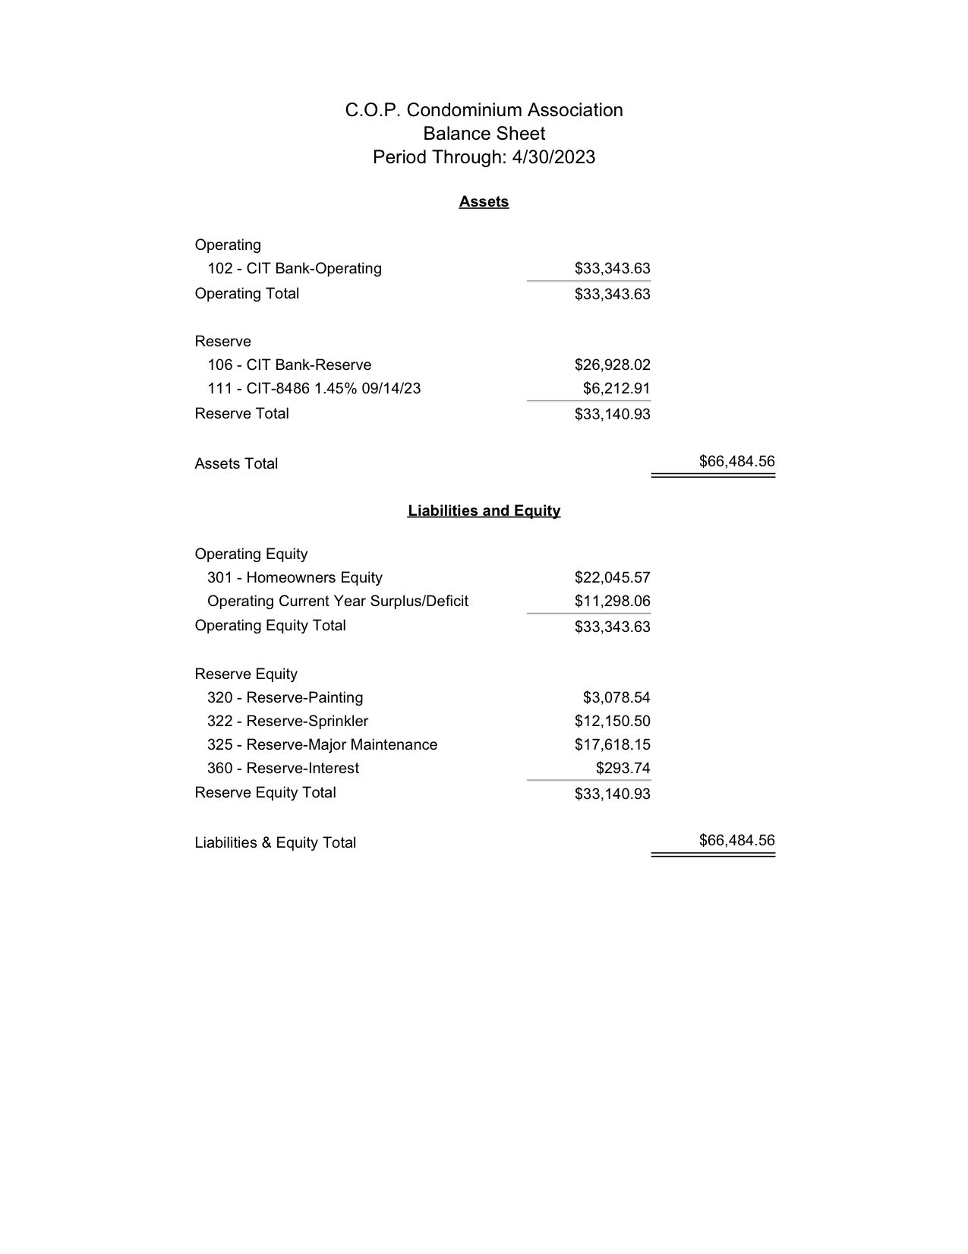
MOTION TO ADJOURN: At 10:52 am made by Ken Davis and seconded by Patricia Sannerud.
